
THE LIGHTHOUSE

Newsletter for May 2015

The night is nearly over; the day is almost here. So let us put aside the deeds of darkness and put on the armor of light.
Romans 13:12

Message from Our Pastor

The process for calling a new full-time pastor is progressing. On May 19, Assistant to the Bishop Katherine Finegan will meet with the councils of Zion and Trinity to present the resume of a potential candidate. Upon review of the candidate’s information, the councils will decide whether or not to interview the candidate in person. If they decide to interview the candidate, a date will be chosen and the candidate will come to St. Ignace and Brevort. If that interview goes well, the councils will recommend the candidate for call, and the candidate will get the chance to meet the people of the congregations. As soon as possible, the congregations would then meet to vote on whether or not to call the candidate and on the candidate’s salary and benefits package.

Please keep the council members in your prayers as they consider this candidate, and also pray for the synod staff as they work to find suitable candidates for ministries across our synod.
---------------------------------------------

Are you looking forward to spring and summer? I sure am. My wife, Alison, and I are joyfully discussing the list of projects to work on to repair or upgrade our house, the plans for the garden that needs to be prepped and planted, and the plans for hosting family when they visit on vacation. Activity around our home really picks up this time of year.

While activities around the home and family can pick up in the spring and summer, activities around the church usually cut back. This is normal in the UP as we take the opportunity to enjoy the outdoors and do some traveling during the few months of nice weather. However, one church activity that never takes a warm-weather break, or even slows down, is weekly worship.

Every Sunday, the church will provide a time for worship. Every Sunday someone will be at church to lead worship in word and music and holy meal. Every Sunday we will have the chance to honor God with our worship and to serve our neighbors by adding our presence, and encouraging voice, and friendly smile, and listening ear to the gathering of people who come to share worship with us.

Our presence at worship matters to God and to those who will gather with us. My prayer is that it will matter enough to us that we will make it a regular part of our spring and summer activities.

May the blessing of warmer weather fill you with gratitude and joy, and lead you to worship!

Pastor Matt Lamb
Interim Pastor

Noisy Offering

The noisy offering for May 3rd will go to the ELCA Disaster Response.

Newsletter

The May Newsletter was adopted by
Vern and Ruth Johnson
in gratitude for their many blessings.

Confirmation

Confirmation will meet on the first two Wednesdays of May at 7 pm. On Wednesday May 6th, Pastor Lamb will be here to meet with the confirmands. On May 13th, it will be Pizza Night.

Confirmation Sunday is May 31st. Congratulations to Madison Olsen and Sarah Doran!

Synod Assembly


Jerry & Susan Fenlon will be gone to the Synod Assembly on May 15th through noon on May 17th. We are collecting quarters for World Hunger that they will be taking to the Assembly.

NOIZ

NOIZ will meet on May 17th at 7 pm for the last meeting until fall.

Search for a Pastor


The Joint Council will be meeting with Rev. Katherine Finegan at 6:30 pm on May 19th at Trinity Lutheran Church. She will be presenting two possible candidates for the Pastor of Trinity & Zion. Keep your fingers crossed.

Sub Sale


Zion Lutheran Youth Group of St. Ignace will be selling subs to raise money for three of our youth to attend the National Gathering in Detroit. There is a sign-up sheet at the back of the church for anyone wishing to purchase subs to support this great cause. You may also contact Shannon Doran at 906-630-2034 to order. Subs are $3.50 a piece and will include bun, cheese, ham, bologna and salami. Checks made payable to WELCA. Subs will be delivered on or after May 20th.

Anyone wishing to donate for the Gathering, just check youth on your weekly contributions. Or send check to the church with Youth Gathering on the subject line.

Christiansen Memorial Lunch

On May 29th at noon we will be having a Memorial Luncheon in honor of Warren & Eleanor Christiansen at Zion.

Thanksgiving for Baptism

On Easter Sunday we were blessed with water from the Baptismal Font. (Photo by Hilda Ryerse)

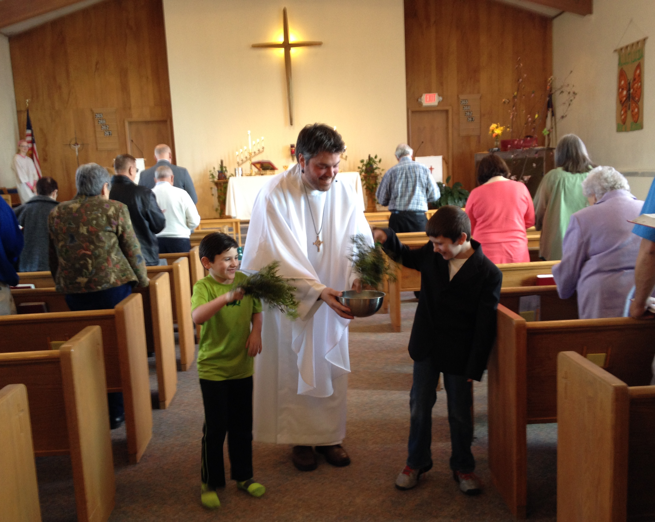

Thank You!

We would like to give a big
“THANK YOU” to Daniel Litzner
for donating the new chalice and
ciborium to Zion. They are very much
appreciated!

Birthdays in May

Shannon Doran 3
Danielle Ford 5
Karen Schlehuber 5
Gracia St. Andrew 5
Loni LaJoice 6
Brian Olsen 6
Ben Idalski 7
Dianne Nelson 9
Bob Brandstrom 12
Gavin St. Onge 16
Tom Gustafson 19
Lynn Evans 21
Debbie Therrian 23
Eric Therrian 25
Jody Harju 27
Charlie Stenson 28
David LaVake 29
Tracey McCluskey 29
Michael Valletta 29

Wedding Anniversaries in May

Nancy and Ken Hardy 1
Tom & Joyce Gustafson 2

Fred & Sandy Feleppa 6
Cliff & Delores Marshall 11
Jeff & Lisa Gamble 24
Jeremy & Liz Winter 25
Wade & Kathy Marshall 31

Baptismal Anniversaries in May

Ruth Cope 4
Judy Ryerse 4
Shannon Martin 6
Cody Swagger 6
Ben Paul 10
Danielle Paul 10
Page Paul 10
Amber Ryerse 16
Susan Fenlon 20
Patric Schlehuber 21
Ethan Shepard 22
Ernie Vallier, Jr. 27
Shirley Winberg 30

Prayer List

(If you would like someone added to the prayer list, call the church at 906-643-7870)

Jim Dyer, Carl & Mary Belonga, LaTaunya Paquin, Phil Richel, Joy Olsen Marolf, Barb Lehto, Jackie Kallstrom, Charlie Lamoreaux, Beth Ann Amacher, Joel Morabito, Joanne Truman, Greg Mitchinson, Kelli Morrison, Ric Mulholland, Jim Rose, Troy Johnston, Dave Movalson, Pega Kennedy, Jim Ryerse, Steve Ingalls, Tom Coffey, Jacqueline Dell and the family of Marla Carr


Contact Information

Interim Pastor: Pastor Matt Lamb may be reached at 717-805-4210 (please call anytime you need to!)
Church telephone: 906-643-7870 - Answering machine
The secretary will usually be in the office on Tuesday and Thursday mornings.
To email the church is: ziontrinity950@yahoo.com
The website is at http://zionstignace.com/home.html
- Find us on facebook at www.facebook.com/zionstignace

Zion Evangelical Lutheran Church and Trinity Lutheran Church are congregations of the Northern Great Lakes Synod and the Evangelical Lutheran Church in America.

Trinity Lutheran Church, W4528 Fishermans Drive, Moran, MI 49760. Worship Service: Sundays at 9 a.m.

Zion Evangelical Lutheran Church, 999 S. State Street,
St. Ignace, MI 49781. Worship Service: Sundays at 11 a.m.

Trinity Worship Families

May 3 Chalmers Family
May 10 Gustafson Family
May 17 Rose Family
May 24 Movalson Family
May 31 Baron Family

Zion Funeral Committee April-July

Team Leader: Linda Wilkins (643-7710)
Co-leader: Marialana Nygard (213-643-9519)

Servants for Zion

Ushers & Greeters
May 3 Lana Lennington & Family
May 10 Delores & Cliff Marshall (Mother’s Day)
May 17 Nicole, Cole, and Alicia Garen
May 24 Bob Marshall and Faith Gaubault
May 31 Confirmation Youth (Confirmation Sunday)

Lectors
May 3 Rita LaVake
May 10 Paul Shepard
May 17 Lynn Evans
May 24 Loni LaJoice
May 31 Betsy Turf

Communion Assistants
May 3 Nicole Garen
May 10 Paul Shepard
May 24 Lorraine Graham
May 31 Lana Lennington

Acolytes
May 3 Kennedy Kammers
May 10 Donovan Insley
May 17 Ryan LaVake
May 24 Matthew Valetta
May 31 Drew Stokero

Altar: Karen Schlehuber
Money Counters: Nicole Garen & Lana Lennington

We will be hosting the service at Long-Term Care on May 10th. Please help out if you can.

Council Meetings

Joint Council - 6:30 pm, May 19th
Trinity Council Meeting – 6 pm, May 18th
Zion Council – 6:30 pm, May 14th

Zion’s Council Members

President: Lana Lennington 643-6576
Vice-President Paul Shepard 984-2069
Secretary: Lorraine Graham 643-8419
Co-Treasurers: Dawn Akers 643-7552
Co-Treasurers: Lana Lennington 643-6576
Fred Feleppa 643-6793
Jerry Fenlon 643-8730
Nicole Garen 298-0490
Tim Idalski 643-6574

Trinity’s Council Members

President: Jerri Rose 292-5570
Vice-President Tracy Movalson 292-5581
Secretary: Sharon Chalmers 292-5440
Treasurer: Pega Kennedy 292-5633
Co-Treasurer: Jim Rose 292-5570
Financial Secretary: Joe Chalmers 292-5433
WELCA: Pega Kennedy 292-5633
John Kennedy 292-5633
Jim Dyer 292-5433
Lois Movalson 292-5581

Joint Council Meeting
April 9, 2015

Present: Sharon Chalmers, Tom Gustafson, Pega Kennedy, John Kennedy, Tracy Movalson, Lana Lennington, Nicole Garen, Jerry Fenlon, Lorraine Graham, Pastor Lamb, Tim Idalski, Jeri Rose, Jim Rose, Fred Feleppa and Dawn Akers.

Pastor Lamb stated that there are a few candidates available if we can get our information in, in a timely manner.

The meeting was opened with a Prayer.

We started with the Financial Package. Then we reviewed each other’s information that we are submitting into the Ministry Site Profile. Pastor Lamb again stated the need to get our paperwork in a.s.a.p. Tracy and Lana agreed to getting it in by the next day.

Joint meeting was adjourned at 8:30 pm.

Zion Lutheran Council Meeting
April 9, 2015
Present: Lana Lennington, Nicole Garen, Jerry Fenlon, Lorraine Graham, Pastor Lamb, Tim Idalski, Fred Feleppa and Dawn Akers.

Our Council meeting started with the end of the Joint Meeting.

The Treasurer’s Report was accepted as presented.

Old Business:

We have received the confirmation presents to be given to Madison Olsen and Sarah Doran. We decided on which form to use and that Pastor Kaiser should sign them. Lorraine was reminded to enter the information into the Parish Record Book. Pastor Lamb mentioned we still need to get it updated before the new pastor arrives.

Jerry went over a few estimates for the repairs to the parsonage windows.

We have not heard anything back from Spartan about collecting labels. Nicole said she would look into it.

Jerry asked if the elevator had ever been fixed and we think that it is. Pastor Lamb, as well as a few others, has taken it for a test drive.

Getting our emails seems to be hit and miss. Nicole said she would see if she could figure out the problem.

New Business:

Pastor Lamb stated he would send Lorraine the Pulpit Supply lists for May and June.

After some discussion we decide that Zion had no High School Seniors graduating this year.

There was a discussion about a phone call from Sandy Feleppa regarding a Synod bus arriving on July 14th. No decisions were made until Nicole could talk to Sandy for a clarification of what she meant.

As far as we know, no student will be going to Fortune Lake this summer. Any funds raised will be going to the trip to Detroit.

There was a discussion on whether the Lutheran women could cater a lunch for the Masonic Lodge on May 30th. It was suggested that we get in touch with Linda. There will be a Memorial Luncheon on May 29th for Eleanor and Warren Christiansen which Lorraine will mention in the Newsletter.

There was a questioned called in about whether we had an Outreach Program. Lana stated they should get in touch with the Hope Chest.

Lorraine asked if the Lifeline Screening people had got in touch with Lana regarding using the church. She said no one had but that we usually let people use the church for such things, in case they called again. It would be without charge but donations would be accepted.

Someone called about doing Community Service. Lana said to tell her to also call the Hope Chest.

We discussed the calendar for May. We will have a NOIZ meeting, which will be the last until fall. Council will meet on the 14th if Pastor Lamb can make it.

Lorraine asked if anyone knew how we got the palms burned to use the ashes for Ash Wednesday. It was the general consensus that the Pastor usually does this. Someone suggested that Mike Herman might do it or save them for the new pastor if we can get one.

Lana stated that there would be no Confirmation Game Night but that the last meeting before summer would be a Pizza Party. She also stated the Pastor Lamb would be meeting with the confirmands on the first Wednesday in May.
The meeting adjourned with the Lord’s Prayer at 9:15 p.m.

Respectfully submitted,
Lorraine Graham

Trinty Lutheran Council Meeting
April 27, 2015

Those Present: Pega and John Kennedy, Jim and Jerri Rose, Tom and Joyce Gustafson, Lois Movalson, Sharon Chalmers, and Pastor Matt Lamb.
OPENING: The Devotional came from our Synod and covered questions concerning how our faith works in our daily lives.
PASTOR'S REPORT: Read and Approved
SECRETARY'S REPORT: Read and Approved
TREASURER'S REPORT: Read and Approved
FINANCIAL SECRETARY’S REPORT: Read and Approved
OLD BUSINESS
1. Stained Glass/ Alan Staige
2. Alter Painting/ Jennifer Lis - Allenville is needing work done on their windows and painting; and, they have also contacted both Alan and Jennifer. The cost will be cheaper if both church's work could be done at the same time.
3. Zion's Youth group is making a trip to Detroit and our council voted to designate the noisy offering from February-June to be used for their trip.
NEW BUSINESS
1. Congregational Report / needs to be filled out and sent ASAP
2. Pega/Insurance and Investments - Pega showed our insurance policy to Pastor Matt. He suggested it looked typical of other church policies that he has seen. Investments will remain untouched for now.
3. Sunday Service Time change - Trinity discussed the possibility of changing our church time and we decided to table it for one month.
4. We will call for estimates to replace the ceiling in the dining room.
5. Trinity is hosting a conference clergy breakfast on May 6 at 9:00.
6. A joint meeting will be held at Trinity on May 19 at 5:30. It will begin with a potluck, then followed by a Review of the candidate's paperwork.
Respectfully Submitted,
Sharon Chalmers, council secretary

Spartan Labels

We are now collecting Spartan Labels to raise money for Zion. Collect the UPC labels from any Spartan product and bring them to the church.
Melodies in May - Dinner & Music

Zion Lutheran Church of Allenville
Saturday, May 2, 2015 - 5:30 pm – 7:00 pm
Youth Fundraiser: Piano Solos, Vocalists, Choir Pieces
$10 minimum donation requested for lasagna, salad, breadsticks, dessert and beverage*.

Seating is limited. Please call or email to make a reservation and leave your name, phone number and how many are attending. Phone: (906) 748-3260
Email: sandylitzner@gmail.com

*Food is prepared in homes and brought to the event.

Hiawatha National Forest Clean-Up Day
May 9th is this year’s Hiawatha National Forest Cleanup Day from 9 a.m. to 2 p.m. Volunteers will meet at 9 a.m. in the Castle Rock parking lot, rain or shine, to help clean up trash on public forest lands.

Geranium Sale


The Annual Geranium Sale in aid of the Mackinac Straits Health System Foundation will be on Friday, May 22, 2015 from 10 am to 5:30 pm at the St. Ignace Greenhouse on Bertrand Street. You can pre-order from Shannon Doran (643-0456) or any volunteer member. The cost is $4.25 per plant.

Vacation Bible School

Vacation Bible School at Zion Evangelical Lutheran Church of St. Ignace. August 10-13, Mon-Thurs, 6 pm - 8 pm

Mike Herman (984-2089) leads the Food Team and will be asking for your suggestions.

Thank You!

We would like to give a big “THANK YOU” to Pastor Mike Herman for donating the new linen to Zion. It is very much appreciated!


News on Nicole

ANN ARBOR, Mich. -- The Big Ten, the nation's oldest collegiate conference, commemorates the 101st anniversary of a very unique tradition, the awarding of the Big Ten Medal of Honor at each of the 14 institutions across the league. The University of Michigan Athletic Department presented the 2014-15 recipients at its annual Student-Athlete Recognition Celebration on Tuesday evening (April 14), with seniors Nicole Elmblad (St. Ignace, Mich./LaSalle) and Justin Glanda (Rochester Hills, Mich./Cranbrook Kingswood) receiving the honor based on their proficiency in scholarship and athletics.
The conference's most exclusive award was the first of its kind in intercollegiate athletics to recognize academic and athletic excellence. The Big Ten Medal of Honor was first awarded in 1915 to one student-athlete from the graduating class of each university who had "attained the greatest proficiency in athletics and scholastic work." Big Ten schools currently feature almost 9,500 student-athletes, but only 28 earn this prestigious award on an annual basis. In the 100 years of the Medal of Honor, almost 1,400 student-athletes have earned this distinction.
The female recipient of the award is Nicole Elmblad from the women's basketball program. She is just the second Michigan women's basketball player to earn the award, joining Diane Dietz, who was the inaugural women's winner at Michigan in 1982. A two-time captain and starter for the Wolverines, Elmblad was a two-time Academic All-American (2014 second team, 2015 third team), three-time Academic All-Big Ten honoree and a two-time Big Ten Distinguished Scholar. Elmblad will complete her degree in biopsychology, cognition and neuroscience at the end of this month and plans to attend medical school.
On the court, Elmblad started all 35 games for the Maize and Blue this season, averaging 7.8 points and 7.0 rebounds per game. She was named to the WNIT all-tournament team and will leave as Michigan as the leader in games played with 133. Her class holds the Michigan record for wins in a career (82) and is the only class to record at least 20 wins in all four seasons.

Win-some Women Christian Retreat

Win-some Women is a fellowship of inter-denominational women drawn together by their common desire to share the reality of Jesus Christ. They invite you to attend their day and a half retreat where you will join with other women for encouragement and inspiration.

This year’s retreat is a two-night stay at the Grand Hotel on Mackinac Island: May 12 & 13, May 13 & 14, or May 14 & 15. Theme: Spiritual Compass – “Looking unto Jesus the author and finisher of our faith” Hebrews 12:2a. To register got to: www.win-somesowmen.org


May Dates to Remember


May 10th: Mother’s Day to honor
everybody’s mom!


May 16th: Armed Forces Day to pay tribute
to men and women who serve the
United States’ armed forces.


May 24th: Day of Pentecost. Wear RED to church!


May 25th: Memorial Day (observed) honors
the men and women who died while serving
in the American military.

